Assignment (ทฤษฎี) ครั้งที่ 2

วิชา 060243103 Problem Solving in IT

ตอนที่ 1

โดย

63-060216-2019-1 นาย สหรัถ ทองอินทร์

ห้อง IT 1-RA

เสนอ

ผู้ช่วยศาสตราจารย์สมชัย เชียงพงศ์พันธุ์

ภาควิชาเทคโนโลยีสารสนเทศ

คณะเทคโนโลยีและการจัดการอุตสาหกรรม

|  |  |
| --- | --- |
| **Given Data** | **Required Result** |
| Product Price  Member Status  Customer Pay | Discount Rate  Member Discount Rate  Price Discount  Member Discount  Net Price  Change |
| **Required Processing** | **Solution Alternatives** |
| Price Discount = Product Price * Discount Rate  Member Discount = Product Price * Member Discount Rate  Net Price = Product Price – Price Discount – Member Discount  Change = Customer Pay – Net Price | * 1. Input data as variable.  2. Input criterion of Discount and Member Discount rate as variable.  * 3. Define criterion of Discount and Member Discount rate as constant.  * is the selected way |

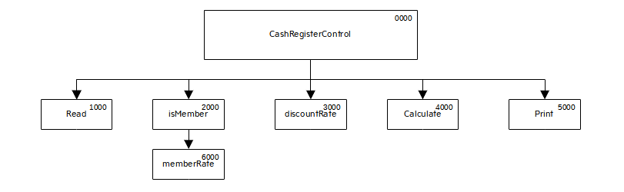

**IPO Chart**

**Problem Analysis Chart (PAC)**

|  |  |  |  |
| --- | --- | --- | --- |
| **Input** | **Processing** | **Module Reference** | **Output** |
| 1. Product Price  2. Member Status  3. Customer Pay | 1. Enter Input Data  2. Calculate Member Rate  3. Calculate Discount Rate  4. Calculate Price Discount, Net Price and Change  5. Print all Required Results  6. End | 1000  2000  3000  4000  5000  5000 | All Required Results |

**Coupling Diagram**

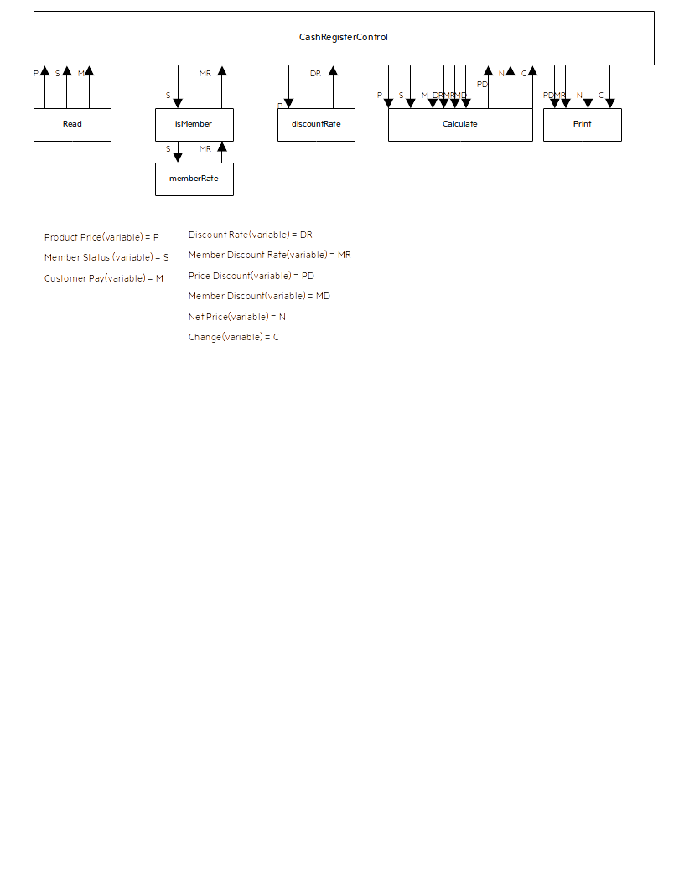

**IPO Chart**

|  |  |  |  |  |  |  |
| --- | --- | --- | --- | --- | --- | --- |
| **Item** | **Variable Name** | **Data Type** | **Module** | **Scope** | **Pseudonym/ Module** | **Error Check** |
| Product Price | price | Real-Numeric | CashRegisterControl/ Read/discountRate/ /Calculate | Local Parameter | None | None |
| Member Status | member | Boolean | CashRegisterControl/ Read/isMember/member Rate/Calculate | Local Parameter | None | None |
| Customer Pay | pay | Real-Numeric | CashRegisterControl/ Read /Calculate | Local Parameter | None | None |
| Discount Rate | discount | Real-Numeric | CashRegisterControl/ isMember/memberRate | Local Parameter | None | None |
| Price Discount | price_discount | Real-Numeric | CashRegisterControl/ Calculate/ Print | Local Parameter | None | None |
| Member Discount | member_discount | Real-Numeric | CashRegisterControl/ discountRate/Calculate | Local Parameter | None | None |
| Net Price | netPrice | Real-Numeric | CashRegisterControl/ Calculate/ Print | Local Parameter | None | None |
| Change | change | Real-Numeric | CashRegisterControl/ Calculate/ Print | Local Parameter | None | None |

**Data Dictionary**

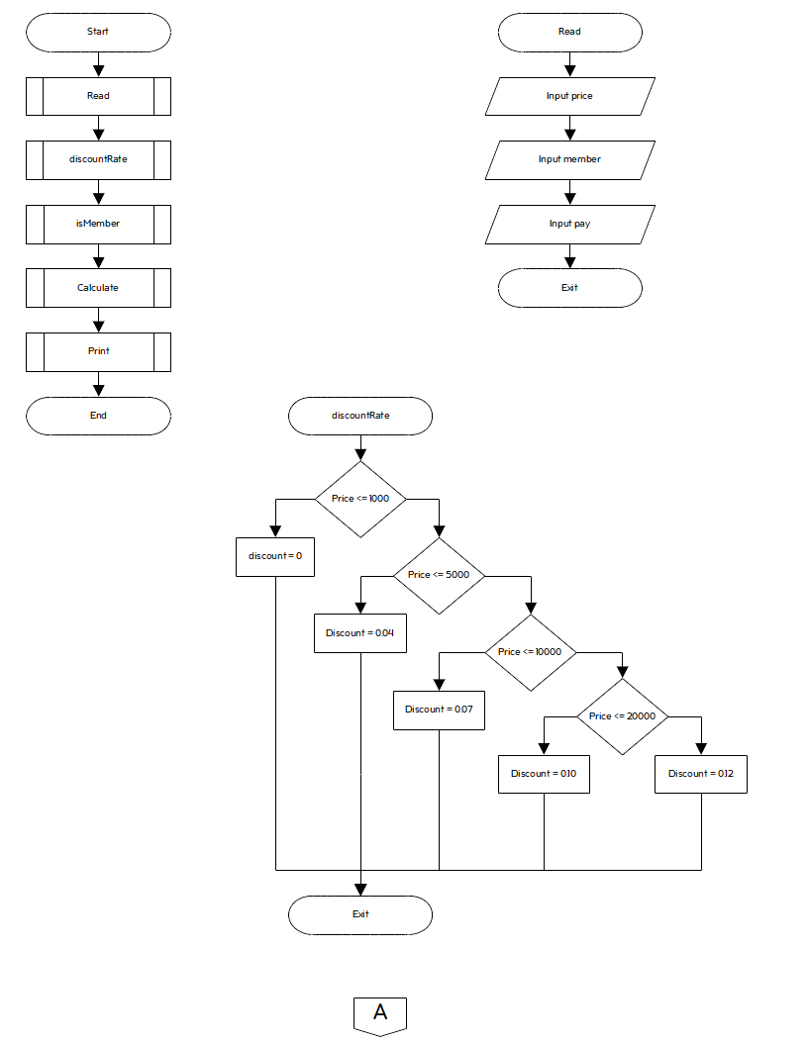

**Flowchart**

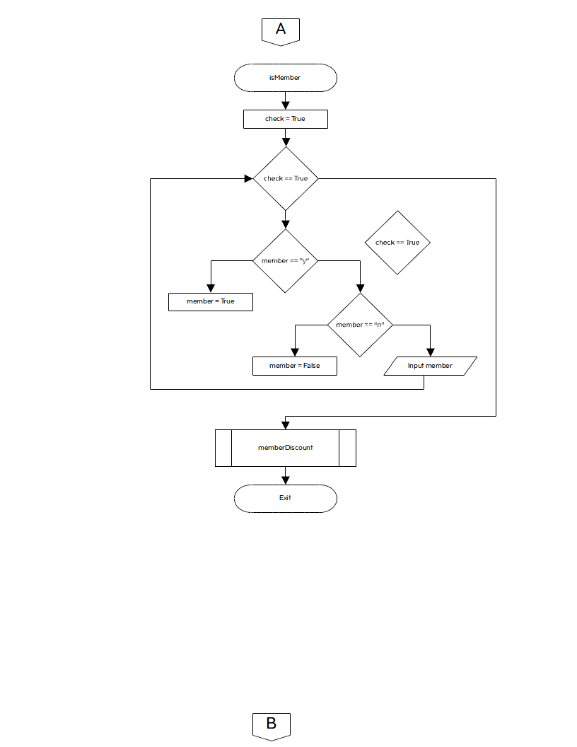

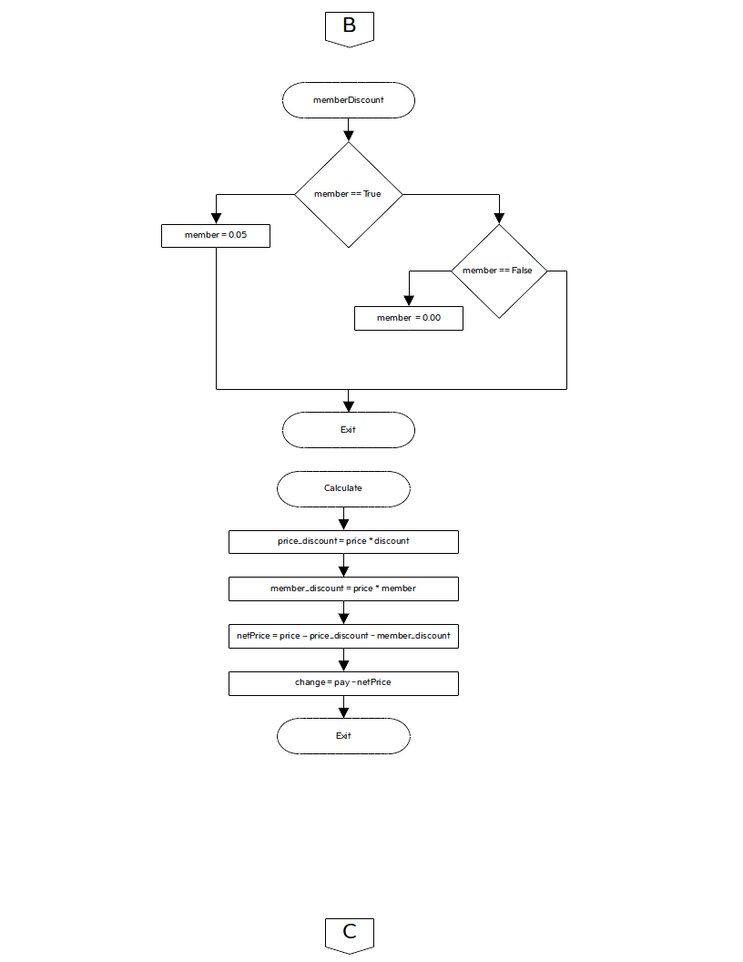

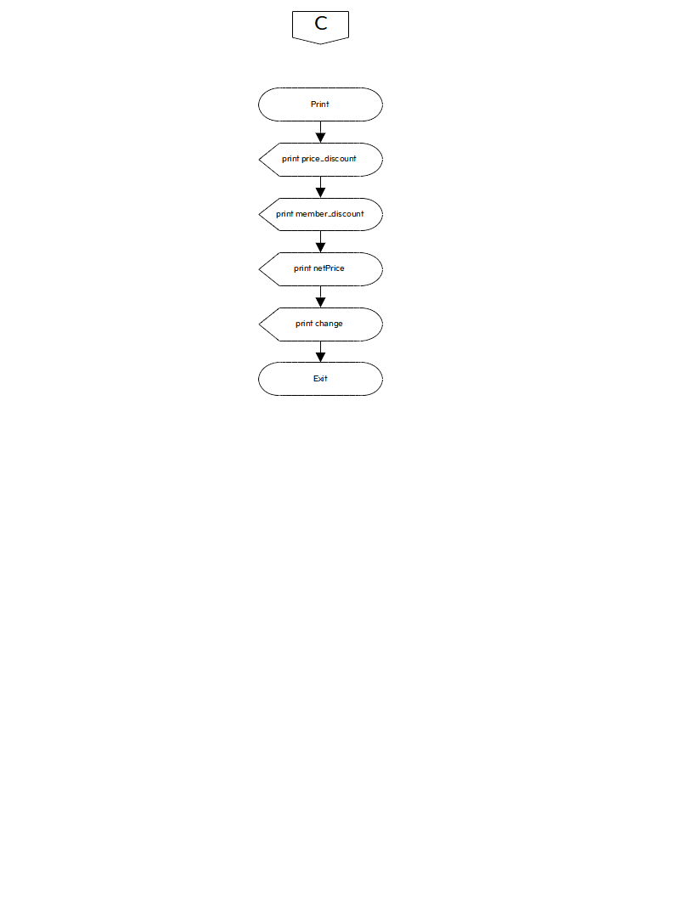

**Code**

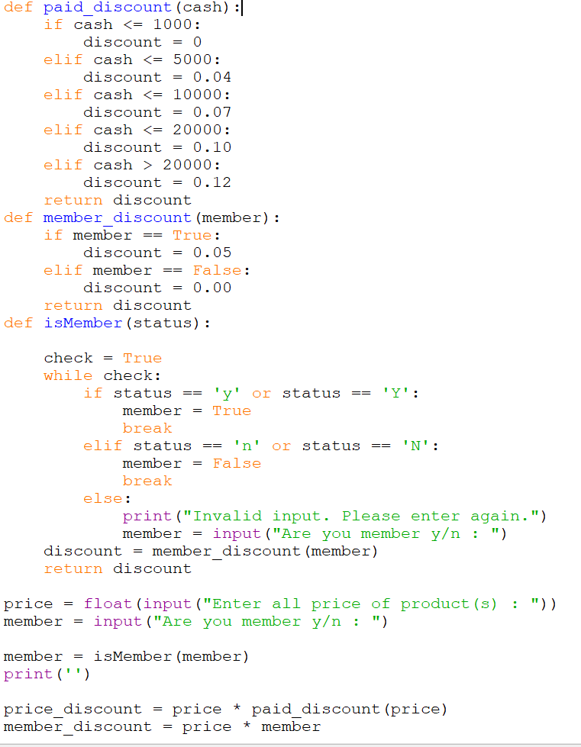

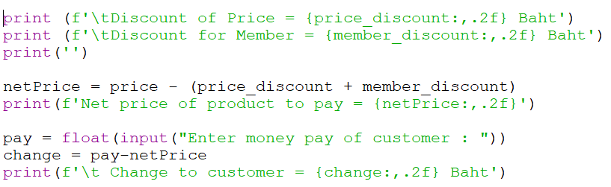

|  |  |
| --- | --- |
| **Given Data** | **Required Result** |
| Subject Name  Score  Credit | Grade  Grade Point  Grade Weight  Sum of Point  Sum of Weight  Grade Point Average |
| **Required Processing** | **Solution Alternatives** |
| Grade point = Grade Weight * Credit  Grade Point Average = Sum of Point / Sum of Weight | 1. Input data as variable.  2. Define Grade and Grade Weight as constant. |

**Problem Analysis Chart (PAC)**

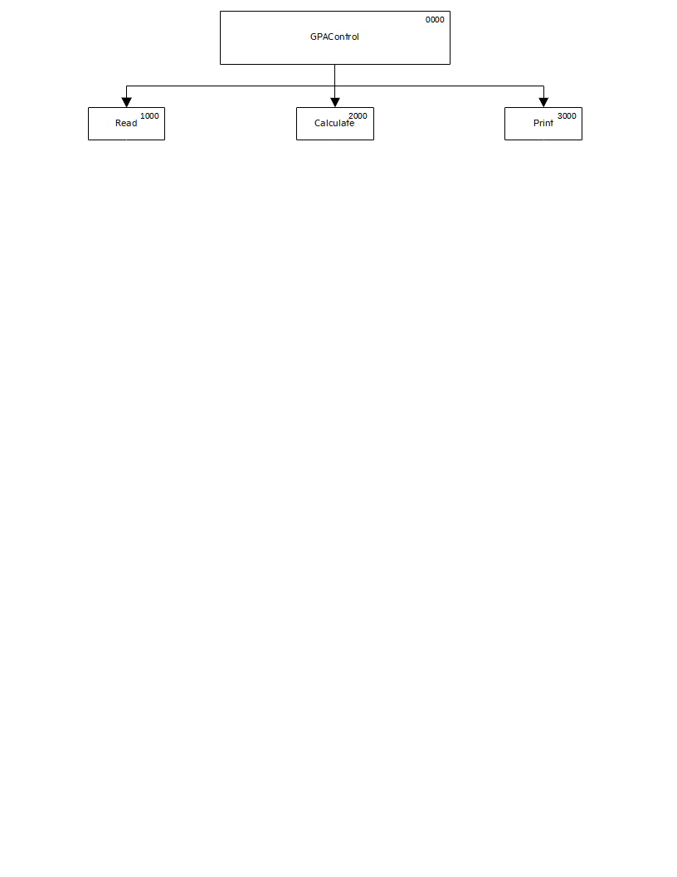

**IPO Chart**

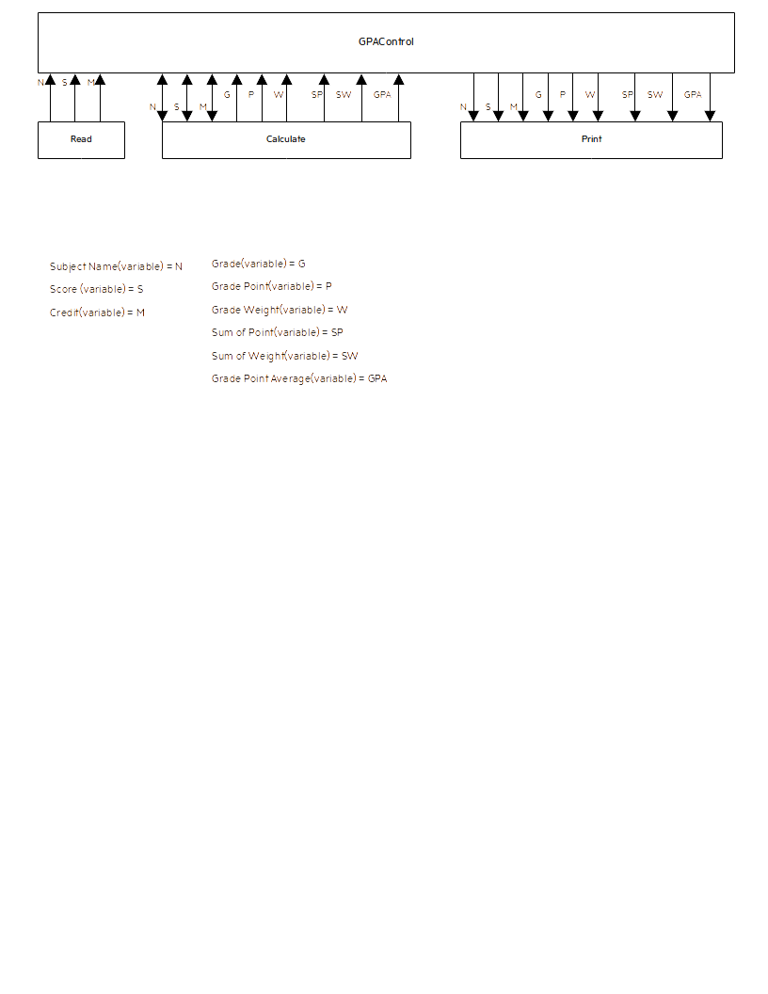

**Coupling Diagram**

|  |  |  |  |  |  |  |
| --- | --- | --- | --- | --- | --- | --- |
| **Item** | **Variable Name** | **Data Type** | **Module** | **Scope** | **Pseudonym/ Module** | **Error Check** |
| Subject Name | name | Charactor | CashRegisterControl/ Read/Calculate/Print | Local Parameter | None | None |
| Score | score | Real-Numberic | CashRegisterControl/ Read/Calculate/Print | Local Parameter | None | None |
| Credit | credit | Real-Numeric | CashRegisterControl/ Read/Calculate/Print | Local Parameter | None | None |
| Grade | grade | Charactor | CashRegisterControl/ Calculate/Print | Local Parameter | None | None |
| Grade Point | grade_point | Real-Numeric | CashRegisterControl/ Calculate/Print | Local Parameter | None | None |
| Grade Weight | grade_weight | Real-Numeric | CashRegisterControl/ Calculate/Print | Local Parameter | None | None |
| Sum of Point | sumPoint | Real-Numeric | CashRegisterControl/ Calculate/Print | Local Parameter | None | None |
| Sum of Weight | sumWeight | Real-Numeric | CashRegisterControl/ Calculate/Print | Local Parameter | None | None |

**Data Dictionary**

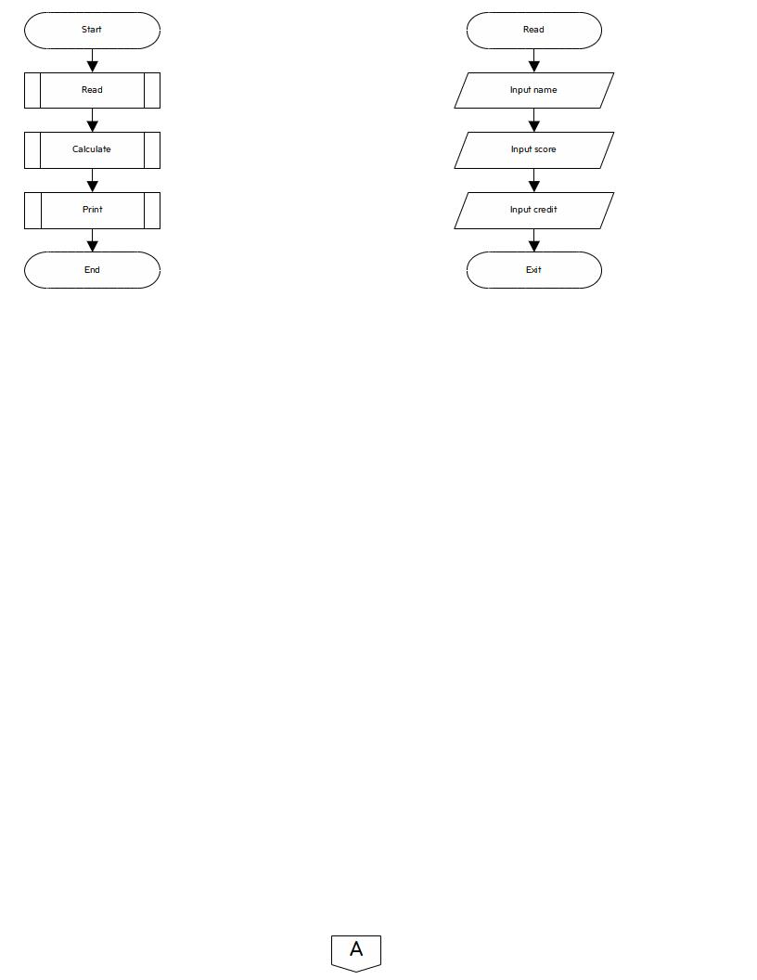

**Flowchart**

